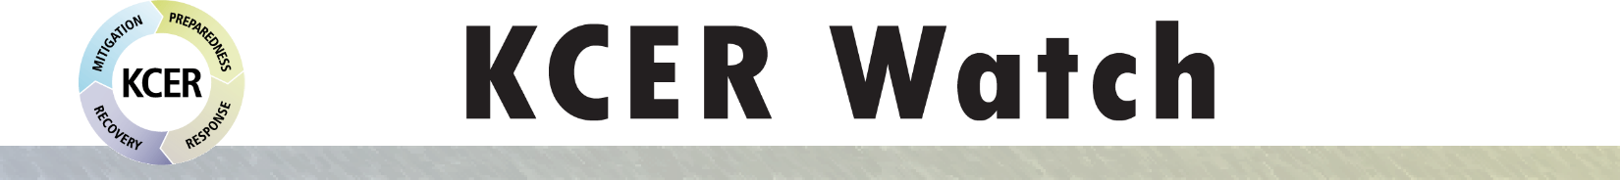

Safety and Health Topics: Emergency Preparedness Bulletin February 2019

In this Issue
Hot Topics
- Protecting Yourself Against Extreme Cold
- “Rehearsal” is the Key to Any Emergency Preparedness Plan
Education/Communication
- Building an Emergency Preparedness Kit for People on Dialysis
- Will You Know What to Do When the Ground Starts to Shake?
- Why Ice Storms Can Be Deadly
- Preparing Your Family Pet for an Emergency

Hot Topics
“Rehearsal” is the Key to Any Emergency Preparedness Plan
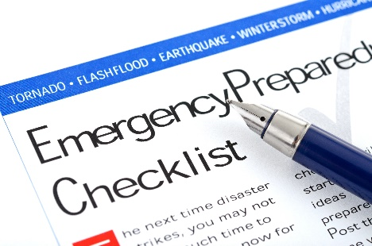
The key to making it through an emergency with minimum harm is to practice your emergency preparedness plan. Practicing a dry run annually can keep disasters from getting the best of you. For dialysis facilities, KCER’s table-top exercises can provide the practice you need.
Read More: https://bit.ly/2LbjnCN
Protecting Yourself Against
Extreme Cold
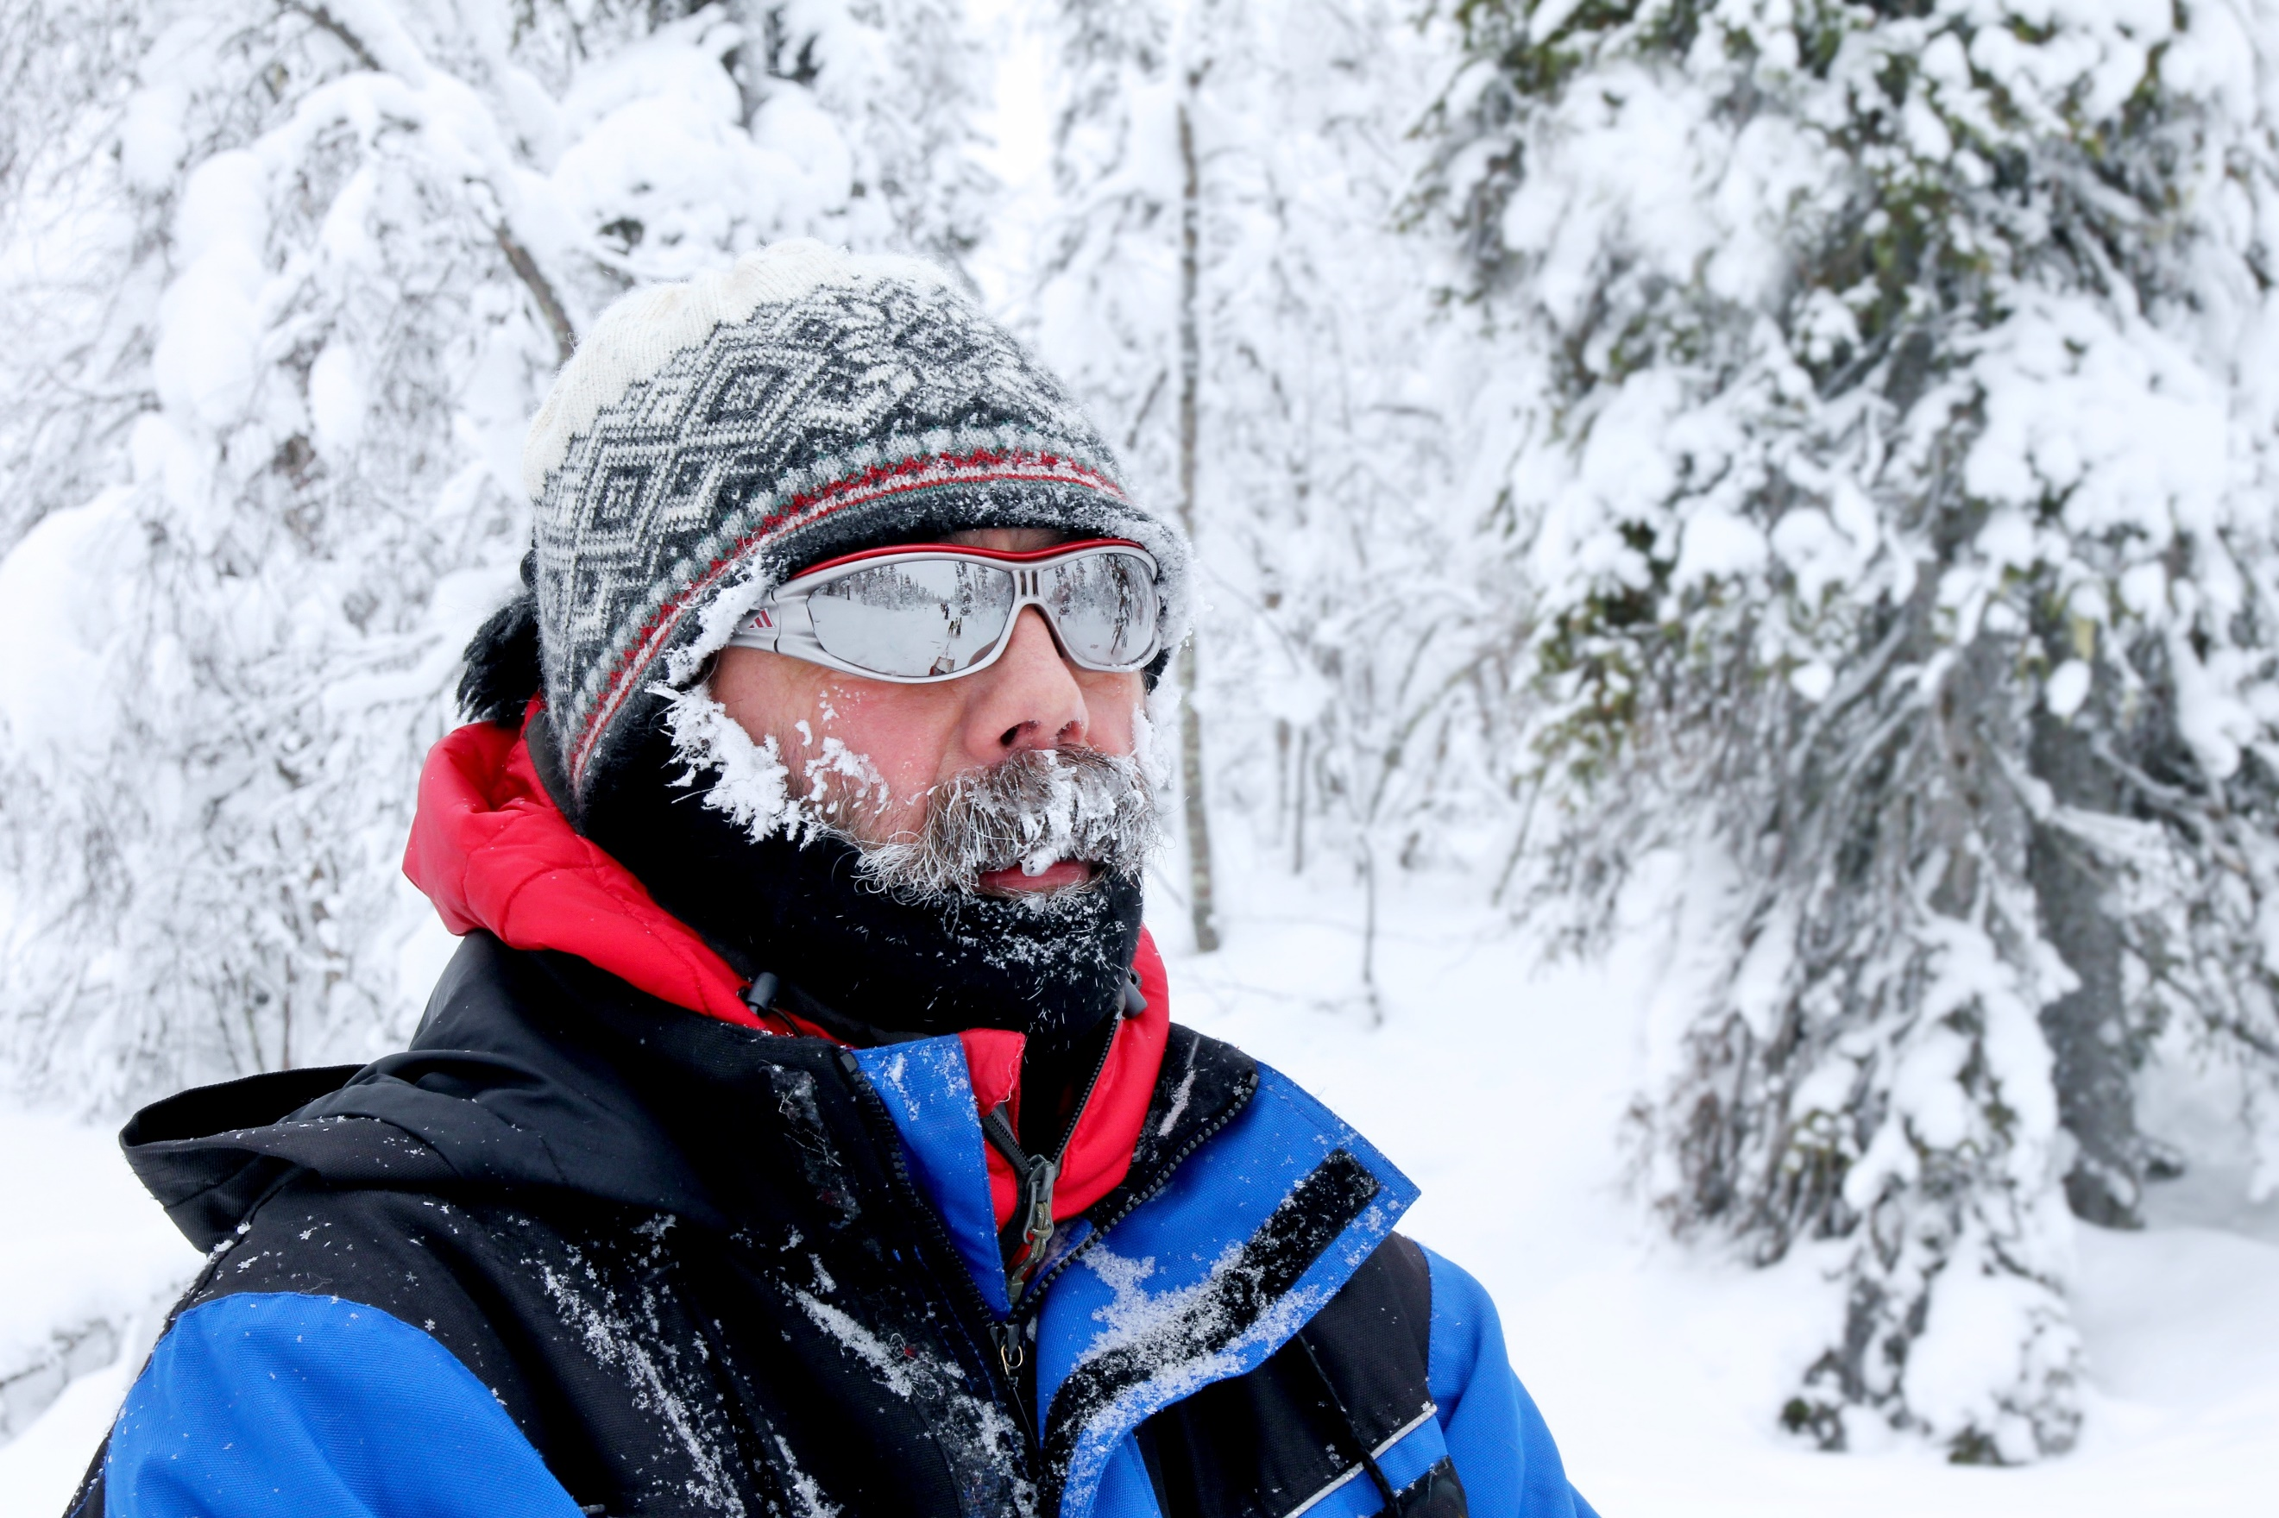
Extremely cold winter days can be dangerous, especially for older adults. Lengthy exposure to very low temperatures, wind, and moisture can lead to frostbite and hypothermia. Even skin that is covered can be vulnerable to frostbite. Click on the link below for ideas for staying safe in the cold.
Read More: https://bit.ly/2aOS2aK

BACK TO TOP

Education/Communication
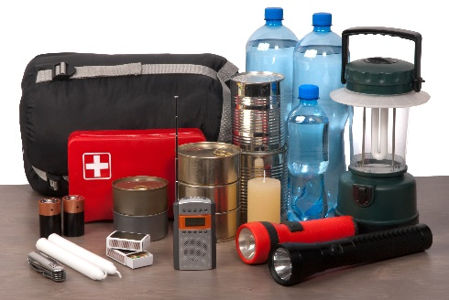
Building an Emergency Preparedness Kit for People on Dialysis
You may have experienced several storm warnings this winter and the season is not over. More winter storms are in the forecast for parts of the U.S. Are you ready? Remember to charge your devices and make sure the batteries in your flashlights are working. Now is a good time to review your emergency preparedness kit. If you need help building one, click on the link below for ideas.
Read More: https://bit.ly/2w0cOgQ
BACK TO TOP

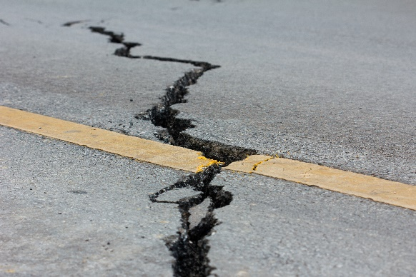
Will You Know What to Do When the Ground Starts to Shake?
Earthquakes are well known to strike the west coast of the U.S., but did you know that earthquakes occur in all regions of the country? There are things you can do to prepare for an earthquake no matter where you live. Making preparedness a priority will help you in a real emergency situation. Here are some tips for before, during, and after an earthquake to help you and your loved ones stay safe.
Read More: https://rdcrss.org/2P2RoXx
BACK TO TOP
Ice Storms Can Be Deadly
When cold rain falls on ground that is below the freezing point, it immediately freezes, causing dangerous conditions. What should you do when the forecast predicts an ice storm? Stay home, if possible. Drive slowly if you must drive. And give others plenty of space on the road. In the link below, the Weather Channel’s Jim Cantore shows you why ice storms can be deadly.
Watch Now: https://bit.ly/2DxW1o9
BACK TO TOP

Preparing Your Family Pet for an Emergency
A little preparation can go a long way when it comes to the safety of your pets in the event of an emergency. While most of us may have an emergency preparedness kit for our human family members, many of us don’t have a kit for our feathered or four-legged friends. There are simple steps you can take today to make sure your pets are safe and cared for in the event of an emergency.
Read More: https://bit.ly/2DBOhBG
BACK TO TOP

You can find this month’s KCER Watch, along with past editions, on our website:
www.kcercoalition.com/kcerwatch

Did you find this edition of KCER Watch helpful?
We want your feedback! Please click here to complete a short feedback assessment: https://www.surveymonkey.com/r/KCERWatchFeb
 | www.kcercoalition.com |  | www.facebook.com/KCERCoalition |  | @KCERProgram

This material was prepared by the Kidney Community Emergency Response (KCER) contractor, under contract with the Centers for Medicare & Medicaid Services (CMS), an agency of the U.S. Department of Health and Human Services. The contents presented do not necessarily reflect CMS policy nor imply endorsement by the U.S. Government. CMS Contract #: HHSM-500-2006-00007C Pub. No.: FL-KCER-7K2T3A-02252019-01

